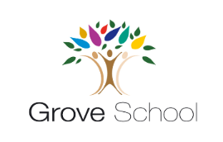
Year 2 Holiday Project
March 2024
Our topic for the next half term is ‘Growing up.’
It is a very exciting topic all about how to stay fit and healthy.
For this holiday project you have a choice of what you can do.
Your options are:
- Make an instructional poster about how to stay healthy. It could be how to play your favourite sport, how to make a healthy meal, how to brush your teeth well or anything else you can think of about being fit and healthy!
or
- Create a healthy and balanced meal. You can present this as a drawing, photo, poster or a model that you have made.
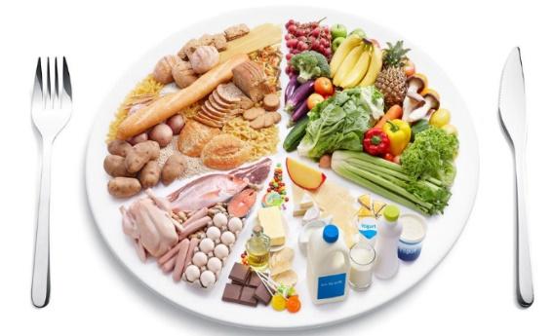
You do not need to do both of them, just pick one that you think you can do really well. Be creative and enjoy!

