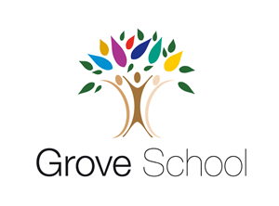
My name is _____________________
Nursery Holiday Project March 2024
Chicks
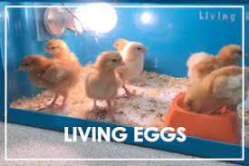
Next term, In Nursery we are very excited to have our very own living eggs.
Can you create a chick or your favourite farm animal using cardboard boxes? Below are some examples.
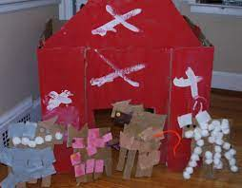
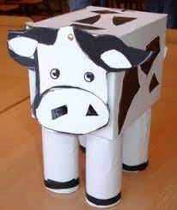
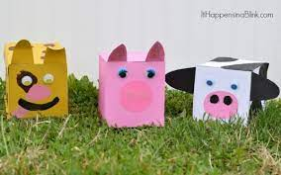

Wedding
Next term, we are also learning about how people celebrations of weddings. Could you bring in a wedding photo of your family members to share with your friends? We are very excited to see all your wonderful pictures.
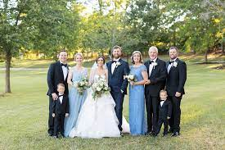

Please return your farm animal and wedding pictures to your teacher on Monday 8th /Wednesday 10th April 2024

